REPORT FOR: | HEALTH AND WELLBEING BOARD
Date of Meeting: | 7th March 2019
Subject: | Disabled Facilities Grants
Responsible Officer: | Nick Powell Divisional Director – Housing Services
Exempt: | No
Wards affected: | All Wards.
Enclosures: | Appendix – Estimated Expenditure 2019-20 to 2021-22 inclusive used to support Capital Bid

Section 1 – Summary and Recommendations

This report sets out the current challenges in delivering statutory Disabled Facilities Grants and our proposals to meet them.
It asks the Health and Wellbeing Board to:

- Note the proposals detailed in the report.
- Authorise the Divisional Director (Housing Services) to write to Central Government on behalf of Health and Wellbeing Board and CCG outlining the Councils concerns.

FOR Decision

Section 2 – Report

Background

The Disabled Facilities Grant (DFG) is a mandatory grant scheme governed by the Housing Grants Construction and Regeneration Act 1996 (HGCR). Applications are open from all tenure types but in respect of applications from council tenants guidance requires that adaptations are to be funded from the Housing Revenue Account (HRA) and not by way of a grant.

The delivery team is the Home Improvement Agency (HIA) based in Housing.
There is substantial evidence that delivering DFGs in a timely manner is cost effective as it makes substantial savings to both social care and health budgets. For example, the most common adaptation, a bath replaced with a level access shower can reduce the risk of falls which is the biggest cause of hip fractures. This intervention reduces potential Care and Health services costs. An FOI request to local authorities in 2015 by Foundations found that: “Within residential care, those who had previously received a DFG moved into care around their 80th birthday, staying there for two years. Those who had not applied for the grant moved when they were 76 and stayed for around six years” The average cost to the Council of a residential placement for the over 65’s is approx. £510 per week, however the benefit would reduce to approx. £360 per week as care in the home is still assumed to be required (albeit at lower levels) for those where the property has been adapted.

Funding

The DFG capital expenditure in Harrow is funded via a mix of central government grant and Council General Fund capital (funded by borrowing). The government has substantially increased the allocation to authorities, there is however a large disparity between the amount that Harrow receives from government in comparison to neighbouring boroughs, a simple calculation based on £/capita on grant shows the following:

Harrow receives approximately £5.65 per head of population for DFGs while Barnet, Hillingdon and Brent receive £9.05, £13.49 and £13.93 per head respectively, this situation has been recognised by Foundations and MHCLG. The current funding methodology has been in place since 2010/11 but is now under review.

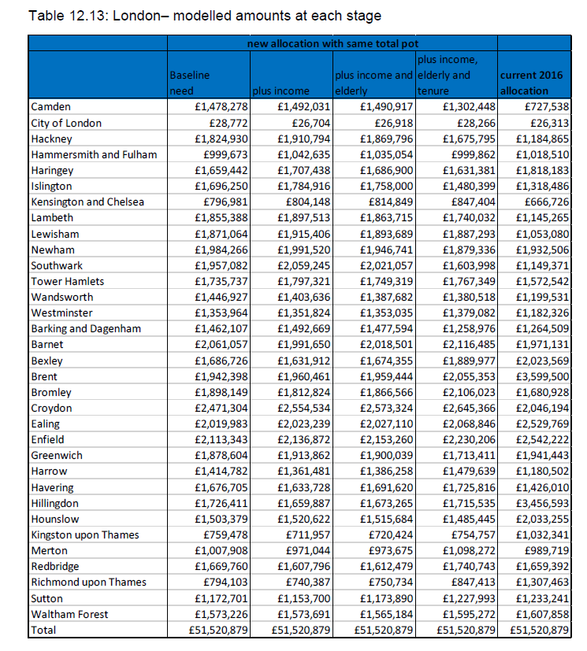

The table above shows individual allocations across London. This is based on 2016 allocations against the assessed need>The needs assessment indicates that the Council funding should be £1.480m v allocation of £1.181m. The current allocation methodology used by MCHLG means that the disparity becomes more pronounced as the total grant increases. Paul Smith (Director of Foundations) said “It's an issue that dates back to 2010/11 and the bids that various LAs made for that year. Brent and Hillingdon bid for twice what they needed and got it, Harrow bid for 78%. Some of today's allocation still reflect those bids”. For example in 2016 the difference between the allocations to Brent and ? Harrow was £2.419m.However in the current financial year (2018/19) this difference increases to £2.937m (an increase of just over £0.5m) with Brent allocated £4.343m and Harrow £1.406m.

When the DFG was first introduced in 1996 there was a legal requirement for local authorities to match fund the grant by 40%. However in 2006 the Government removed this requirement, and other boroughs who received larger contributions were in a position to stop contributing to the grant without effecting service delivery. Harrow, due to the lower allocation indicated above has been unable to do this and has had to continue to contribute to the DFG.

Additional grant allocations were invited in January 2019, and resulted in Harrow securing additional DFG funding of £230k. However it is worth noting that Brent and Hillingdon received an additional £550k and £533k respectively at the same time so the disparity in allocations continues.

The average grant in Harrow is currently £10,400 including fees, (Note: independent research funded by the Health Research (Policy Research Programme National Institute for, Unit Costs of Health and Social Care, 035/0093) gives an average cost for major adaptations nationally of £16,647 so Harrow average cost is well below the national average). https://www.foundations.uk.com/about-us/about-us/our-vision-and-values/latest-news-and-blogs/the-importance-of-unit-costs-when-setting-dfg-allocations/

The HIA charges a fee of to design, supervise and administer the grants, This is permitted under The Housing Renewal Grants (Services and Charges) Order 1996 paragraph 2.

Current position and challenges

The main challenge Harrow faces is that there are insufficient resources to meet the increasing demand for the service. The most significant factor here being the national funding mechanism highlighted above which evidences the level of underfunding for Harrow. As a result, this has required the Council to continue to contribute its own capital to the delivery of DFGs.

Since 2016 the funding for DFGs has been included within the Council’s Better Care Fund to encourage local areas to think about the use of home adaptations, the use of technologies to support people in their own homes, and take a joined up approach to improving outcomes across health, social are, and housing. This approach meets the Council’s prevention duties under the Care Act 2014 and prevents more expensive provision elsewhere. This has resulted in some of the DFG funding being used to fund minor equipment for Adults, occupational therapy, and more recently for Telecare.

Due to the budgetary issues detailed above, the current (financial) year’s budget is now exhausted. The Council has, where appropriate, been issuing deferred payment approvals for the past year, and this this is allowed under the HGCR Act. This allows the Council to issue approvals in accordance with legislation but means payment of individual grants can be paid up to 12 months later. A recent Ombudsman enquiry states that although this is allowed under the Act deferred approvals should as a matter of best practice be issued as an exception

It is estimated that deferrals in the current year will amount to around £800k. If we allow cases to continue to build up then even deferral may not be an option. Without taking action the Council is at risk of an increase of complaints, Ombudsman enquiries and possible legal action. Deferring DFGs can result in higher level care packages being provided as citizens are dependent on carers to provide support – eg with bathing, when a level access shower would enable them to shower independently. In some cases, this could also result in residential or nursing placement being needed.

Another issue identified in a recent Ombudsman enquiry was the waiting list for adaptations. There has been pressure on the Occupational Service to meet the demand for assessments. Our Adults Service has estimated that there are in the region of 240 cases of citizens requesting adaptations. Of the 240 cases on the waiting list it is estimated that 180 of these are potential DFGs. Cases referred into the Occupational Therapist Team are prioritised according to need and the level of risk. Equipment is provided where relevant to meet the immediate needs. Following the OT Assessment, adaptations are prioritised in line with the Adaptations Policy 2018 criteria, and emergency adaptations can be agreed in certain circumstances.

As a result of the waiting list, there are delays in referring cases through to the Home Improvement Agency to begin the process of delivering the work. This means that the throughput of referrals has not been consistent. However, it is estimated that there are approximately 22 new cases coming through per month, which reduces to around 19 per month following dropouts, all requiring adaptations to be funded via a DFG.

There are clear statutory limits in respect of the timescale for deciding upon a completed application and for making the monies available (totalling a year from completed assessment) which if breached could give rise to challenge by way of complaint, referral to the Local Government Ombudsman or judicial review.

There is no statutory timetable for the work to be done to enable a completed application form to be submitted. Most local authorities conduct preliminary assessments to prepare the application for consideration , and operate a waiting list for this work. While there is no direct statutory requirement set out in terms of this pre application process, but it is clear from published Ombudsman reports that any process around starting the formal application process must be administered on a reasonable basis.

Despite the lack of a statutory timetable, it could still be possible to challenge the decisions re pre application process including waiting list on grounds of reasonableness through the complaint process, referral to the Local government Ombudsman or by way of judicial review

The proposed way forward

A cross council working group has been set up to review how Harrow can work within its budgets and meet the demand for DFGs, and when implemented the changes below will have a positive impact as more assessments will be completed on an ongoing basis, so the waiting list will be reduced. More DFGs will be funded in 2019-20, with the increase in capital funding, and if additional funds are made available by government or ongoing additional council funding is agreed, we will able to continue reducing the number of grants deferred to 2020-21, and the following year. Over a three year period, it will be possible to meet the statutory requirements whilst eliminating the backlog of cases, and the need to defer any grants.

1. Increased Council capital funding

Even though the DFG budget it is topped up by the council as detailed above is still not sufficient to meet the demand in the borough. The council is at risk of further ombudsman enquiries, complaints and possible judicial review if it should fail to meet its statutory duty under the HGCR act.

For 2019/20 the Councils capital is considering increasing its contribution by £932k taking the total funding to £2,962,000. This will allow the Council to begin to manage the throughput of DFGs and this will be monitored t throughout the financial year and enable consideration of the budget requirement for 2020/21.

The DFG and minor adaptations and Careline budgets will be separated. This will give clarity on what each budget is used for and allow the Home Improvement Agency to focus on its DFG budget.

2. The Home Improvement Agency to provide a more holistic service and early prioritisation of applications.

A large part of the process in Harrow requires occupational therapist input which has proved challenging given the budget reduction in in 2016/17. This has led to the lengthy waiting list for adaptations, which whilst not unlawful, has been criticised by the Ombudsman ,

The Royal College of Occupational Therapists has over recent years been encouraging the use of Trusted Assessors to carry out assessments for non complex cases. We have recently carried out training as Trusted Assessors and have recently completed the highest level of training available via the Disability Living Foundation. This will enable the adaptations team to carry out around 80% of major adaptations with minimal occupational therapy input, allowing the in house Occupational Therapists to deal with complex cases. Using the Trusted Assessor model we aim to deal with cases quicker and more effectively. Please see the table below which shows the original process using qualified Occupational Therapists and using the Trusted Assessor model.

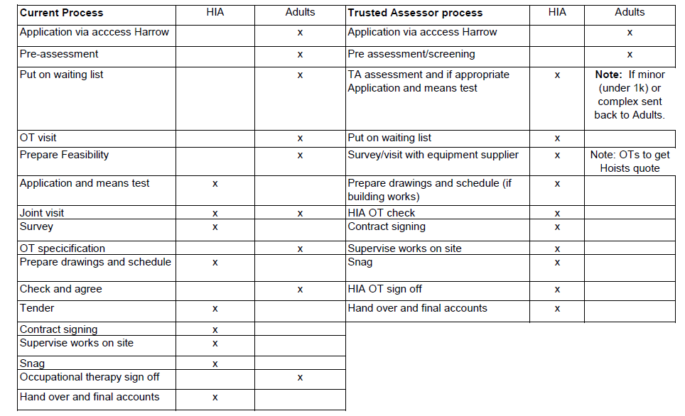

The effect of using this model is that we will be able to deal with cases more quickly, cut out a lot of unnecessary red tape and reduce the burden on scarce occupational therapy resources.

3. Re-introduction of means testing, and cap on expensive schemes

Means testing has been reintroduced to ensure that those most in need are prioritised for funding and those who are able to pay for their own adaptations (subject to financial assessment) do so. Expensive schemes such as property extensions for adult adaptations will no longer be funded unless there are exceptional circumstances, with just the adaptation element of any scheme being funded. This is in line with practice in many other local authorities. We will also ensure that we continue to benchmark against other Council’s policies in an effort to manage demand.

4. Aspire to reduce the need for DFGs through the vision

The Adults Services vision has been developed to respond to the continuing rise in demand for health and social care services at a time when funding is decreasing. Community resilience can be defined as empowering citizens to maintain their well-being and independence, strengthening support networks within their families and communities; enabling them to be stronger, healthier, more resilient and less reliant on formal social care services.
The transformation of adult social care seeks to utilise community assets, strengthen local networks and integrative pathways and give better access to community resources.
This transformation will include the development of extra care housing provision which will provide adapted accommodation to support care needs for the residents of Harrow and the reintroduction of means testing will require those who can pay for their own adaptations to do so. Over time it is expected that these approaches will reduce the level of need for DFGs enabling demand to be managed within the financial envelope.

5. Lobbying of Central Government for a fairer allocation of DFG Funding

Several benchmarking exercises and alternative funding methodologies have highlighted that Harrow is badly served by the historic current funding regime. Changes to an alternative methodology would result in Harrow’s funding increasing by anywhere between £500k and £1m per year. There is strong pressure from Foundations (a body funded by Central Govenrnment to support Home Improvement Agencies)within the consultation for the Social Care Green Paper and the independent report by the University of West England, The BRE, Ferret and Foundations of December 2018 to change this funding methodology. Our discussions with MHCLG indicate central government also recognise this. It is hoped that the Council is treated more favourably by any future changes in the allocations methodology and in support of this, the Health and Wellbeing Board and the CCG are asked to write a joint letter to MHCLG outlining the concerns.

Section 3 – Further Information

No further information added.

Section 4 – Financial Implications

Proposed DFG capital budget for 2019-20 includes £932k additional borrowing to fund estimated expenditure although this increase is for one year only and has not been allocated for 2020-21 onwards.

External grant funding, from the Better Care Fund, has been assumed at £1.180m. Although there have been additional one off allocations of £450k during 2018-19 and indications this grant funding will increase on an ongoing basis, nothing has yet been confirmed by Government therefore external grant funding has been assumed to remain unchanged.

Increases in grant funding will have a positive impact whether by increasing overall capacity or reducing requirement to borrow, or a combination thereof.

Budgets from 2019-20 onwards will be rationalised to by splitting out Teleacre and small equipment to allow easier management. Details are provided in appendix to this report.

The proposed budget and Capital programme for 2019-20 and 2020-21 to 2021-22 requires a review of demand pressures to be carried out as part of providing a more joined up and holistic adaptations service for private residents in the Borough. This, together with further clarity around grant funding, will enable the future DFG funding requirements to be assessed in the context of the wider council financial challenges and the ongoing revenue impact of the costs of increased borrowing.

The appendix to this report sets out the estimated expenditure and funding assumptions. Although ICES (low value equipment expenditure for Adults Social Care) and Telecare will be separated out, this will not change the underlying funding requirement.

Section 5 - Equalities implications

Pursuant to Equality Act 2010 (“the Act”), Council, in the exercise of its functions, has to have ‘due regard’ to (i) eliminating discrimination, harassment, victimisation and any other conduct prohibited by or under the Act; (ii) advancing equality of opportunity between those with a relevant protected characteristic and those without; and (iii) fostering good relations between those with a relevant protected characteristic and those without. Relevant protected characteristics are age, race, disability, gender reassignment, pregnancy and maternity, religion or belief, sex and sexual orientation. Duty also covers marriage and civil partnership, but to a limited extent.

The Public Sector Duty at s149 of the Act requires that the local authority When making decisions, must take account of the equality duty and in particular any potential impact on protected groups.
Clearly the majority of recipients of a Disabled Facilities Grant will be people with a disability , and increasing the funding for the service should lead to an improvement in the service

Currently there are no changes to the Adaptations Policy planned ,and that policy was agreed following consideration of an Equalities
Impact assessment .. Should any changes be proposed a further Equalities Impact Assessment will be carried out.as appropriate

Section 6 – Council Priorities

The Council’s vision:

Working Together to Make a Difference for Harrow

Please identify how the report incorporates the administration’s priorities.

- Making a difference for the vulnerable
- Making a difference for communities
- Making a difference for local businesses
- Making a difference for families

Section 7 – Legal Implications

The duty to provide grants to meet disability needs comes from the Housing Grants, Construction and Regeneration Act 1996, and relevant Regulations (principally the Housing Renewal Grants Regulations 1996)

The Act requires a local housing authority to make mandatory grants to eligible applicants for adaptations up to a maximum value of £30,000, and sets requirements in respect of timescales for dealing with applications. The Act refers to a decision being made as soon as reasonably practicable but applications must be approved or refused no later than 6 months of the date of application

Applications can be made by those in accommodation provided by the local authority, but those adaptations must be met by the LA’s Housing Revenue Account and do not attract grant funding

The payment of the grant following the approval of the application may be delayed to a date not more than 12 months following the date of the application (s36 of the Act set out below), but both the Home Adaptations Consortium Guidance 2013 and LGO report ‘Making a house a home: local authorities and adaptations, focus report learning from complaints’ published in 2016 suggest much shorter target response times should be the norm, with the 6 and 12 month timescales being exceptional.

Delayed payment of mandatory grant.

(1) [The local housing authority may approve an application for a grant on terms that payment of the grant, or part of it, will not be made before a date specified in the notification of their decision on the application.
(2) That date shall not be more than twelve months, or such other period as may be specified by order of the Secretary of State, after the date of the application.

The funding for DFG monies is contained in the annual Better Care Funding settlement, but the BCF is not ring fenced to funding DFGs only.

STATUTORY OFFICER CLEARANCE
(Council and Joint Reports

 |  |  | on behalf of the
Name: Donna Edwards | x |  | Chief Financial Officer
Date: 28 February 2019
 |  |  | on behalf of the
Name: Sharon Clarke, | x |  | Monitoring Officer
Date: 28th February 2019

Ward Councillors notified: | NO

Section 7 - Contact Details and Background Papers

Contact: Mick Sheehy, Service Manager Adaptations, 020 8736 6011

Background Papers:

Average grant costs
https://www.foundations.uk.com/about-us/about-us/our-vision-and-values/latest-news-and-blogs/the-importance-of-unit-costs-when-setting-dfg-allocations/

Charging fees to the grant
http://www.legislation.gov.uk/uksi/1996/2889/article/2/made

Housing Grants Construction and Regeneration act 1996
http://www.legislation.gov.uk/ukpga/1996/53/contents

Appendix – estimated expenditure 2019-20 to 2021-22 inclusive used to support Capital Bid

Item | 2019-20 | 2020-21 | 2021-22
Deferrals from prior year | 767 | 585 | 398
Adaptations (Mandatory under HGCR act) | 1,758 | 1,843 | 1,929
Telecare [Note 1] | 231 | 235 | 240
Small equipment [Note 1] | 230 | 230 | 230
Sub total | 2,986 | 2,893 | 2,797
Deferrals to next year | -585 | -398 | -203
Works & equipment | 2,401 | 2,495 | 2,594
Fees @ 21% of works cost | 458 | 467 | 476
Staffing | 103 | 105 | 107
Capitalisation | 561 | 572 | 584
Estimated spend | 2,962 | 3,067 | 3,177
Approved budget | 2,030 | 2,030 | 2,030
Increase required [Note 1] | 932 | 1,037 | 1,147
Grant | 1,180 | 1,180 | 1,180
Borrowing | 850 | 850 | 850
Funding [Note 3] | 2,030 | 2,030 | 2,030

Note 1, to be separated out from 2019-20, will not change estimated pressure as budget will be reallocated to ICES and Telecare expenditure

Note 2, Capital bid £932k submitted to Cabinet for approval.
Additional budget for subsequent years not included pending review of demand and processes

Note 3, potential increase in grant funding not included as nothing yet confirmed

